***Geek God***

* Make sure the instance of mongoDb is running
* Run MongoDB
* Open the command prompt
* Go To Project Directory where **package.json** file is present
* ***D:\GeekGod\GeekGod***
* To execute the project type **node server.js**

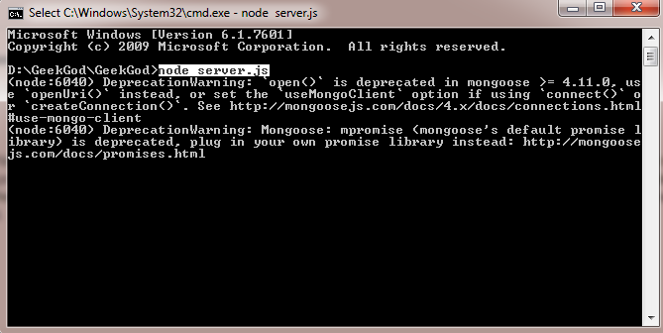

* Type localhost:2900 to launch the website
* 
* 